**Document History**

|  |  |  |  |  |  |  |  |
| --- | --- | --- | --- | --- | --- | --- | --- |
| **Document Name** | **Version** | **Status** | **Date** | **Viewable** | **Reviewer** | | **Responsible** |
| **Documents** | | | | | | | |
| TEAMDUTY-Proposal-V.0.1.docx | - Add Chapter 1  -  - Add Chapter 2  - Technology Review  - Development Tool Review  - Add Chapter 3  -  - Add Chapter 4  - Motivation  - Aims and Objective  - Deliverables and Limits  -Add Chapter 5  - | Draft | 6 Feb 2014 | MM,  SN,JH | | MM,  SN | MM,  SN |
| TEAMDUTY-Proposal-V.0.2.docx | - Add Chapter 1  - Introduction & Background  - Add Chapter 2  - Business Review  - Business Tools and Software Review  - Technology Review  - Development Tool Review  - Add Chapter 3  - ISO29110  - Add Chapter 4  - Motivation  - Aim and Objective  - Deliverables and Limits  - Future Work  - Schedule & Milestone  - Add Chapter 5  - References | Draft | 6 Feb 2014 | MM,  SN,JH | MM,  SN | | MM,  SN |
| TEAMDUTY-Proposal-V.0.3.docx | Change some sentence within  - Introduction & Background |  |  |  |  | |  |

**\*MM = Manuchet Manoi**

**\*SN = Saknarong Noipaksa**

**\*JH = Jahakrit Hirisajja**

Table Content

.

# **Chapter One | Introduction and Background**

There are many roles of technologies in modern times. For example, smartphone, computer or tablet. These technologies are important factors in the production first is “Hardware” component that resembles a skeleton can be seen with the eye and touch and the second is a “Software” program or batch processing functions to control the external device(Hardware). This is extremely important for production of those devices

Currently software has a role to human life in more modern times. It causes to occur software industry, both domestically and internationally. The process of producing software that requires a multi-step process and the theories ideas of human came over to be software high quality.

At each stage of software production must be a professional personal in each field. In order to get the software quality as expected, That will be occur problem about personal in each process that have capability mismatch with each software producing process. To help people that have capabilities about software can find a project or task that matches with own capabilities. It must be explained detail of work before publish in each public, for made it surely understand about the project that published

To help entrepreneur solve the problem about human resource. Software freelancer will has role to finish each project that Plan on previously. Because they work on each temporary project. How to know that software-freelancer have skill that match with software-task or software-project or not?

# **Chapter Two | Literature Review**

**2.1 Business Review**

**Overview**

A **freelancer** is someone who performs tasks, usually for multiple employers over the course of a year. A freelancer is somewhat like a free agent in professional sports - he or she essentially sell their services to the highest bidder - except that they usually work for more than one employer.

Freelancers may work part-time or full-time. Because they are not considered employers, freelancers are allowed to work for other employers and are usually permitted to perform tasks in their own way, so long as the work gets done to the client's specifications.

Depending on the industry, freelance work practices vary and have changed over time. In some industries such as consulting, freelancers may require clients to sign written [contracts](http://en.wikipedia.org/wiki/Contracts). While in journalism or writing, freelancers may work for free or do work "on spec" to build their reputations or a relationship with a publication. Some freelancers may provide written estimates of work and request deposits from clients.

Payment for freelance work also depends on industry, skills, and experience. Freelancers may charge by the day, hour, a piece rate, or on a per-project basis. Instead of a flat rate or fee, some freelancers have adopted a [value-based pricing](http://en.wikipedia.org/wiki/Value-based_pricing) method based on the perceived value of the results to the client. By custom, payment arrangements may be upfront, percentage upfront, or upon completion. For more complex projects, a contract may set a payment schedule based on milestones or outcomes. One of the drawbacks of freelancing is that there is no guaranteed payment, and the work can be highly [precarious](http://en.wikipedia.org/wiki/Precarious_work).

**Target**

**-**Find alternative of software task or software freelance personal via web application

**Benefit**

-user can get software task that match with their capability.

-user can get software personal that match with software project.

**2.2 Business Tools and Software Review  
  
2.2.1 www.** **Freelancer.com** [?]

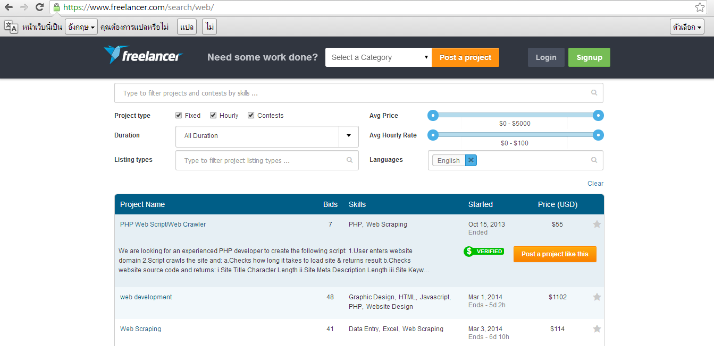

**Figure 2.2.1 www. Freelancer.com**

Freelancer.com is the world's largest freelancing, outsourcing, and crowdsourcing marketplace for small business. With over 10 million users, you can hire a freelancer to do your contract work at a fraction of the cost. Whether you need PHP developers, web designers, or content writers, you can outsource jobs within minutes. Browse through hundreds of skills including copywriting, data entry, and graphic design or more technical areas like coding HTML, programming MySQL, and designing CSS. Are you an entrepreneur just starting a company? Find a quality graphic designer to create a logo to your specifications. Once you get new customers rolling in, you can even hire customer support or a virtual personal assistant to simplify your life without the risky overhead and cost of hiring full-time staff. From beginning to end, Freelancer.com makes it easy to hire freelancers and find freelance jobs online.

**Pros**  
 - freelance.com deals with all the documents meaning you save time  
 - The certificate provides a guarantee for the employer that you are complying with the current laws  
 - largest online marketplace for freelance workers.

**Cons**

* Posting a job need some money depends on manner of task.
* To get the job, members have to bid.
* To find project, only searching are allowed.

**2.2.2.** **www.108freelance.com**

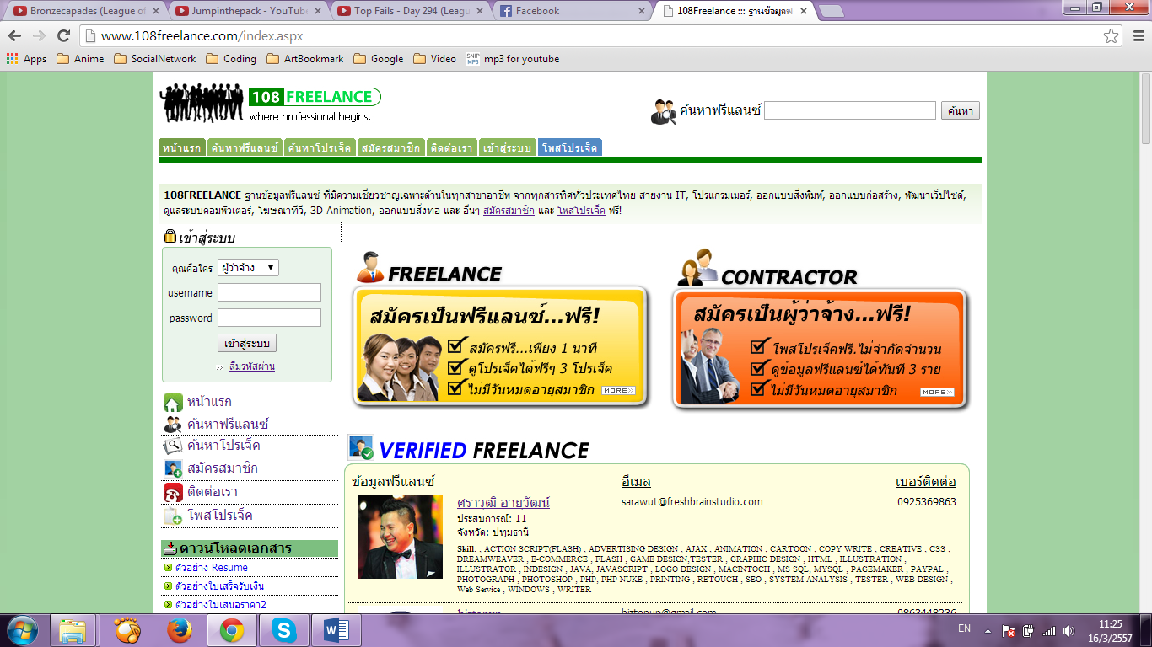

**Figure 2.2.2 http://www.108freelance.com/**

**Pros**  
 - update news about freelance everyday

- have example document of resume and contract form

**Cons**

- 108freelance.com support only Thai language

- very complicate register before using.

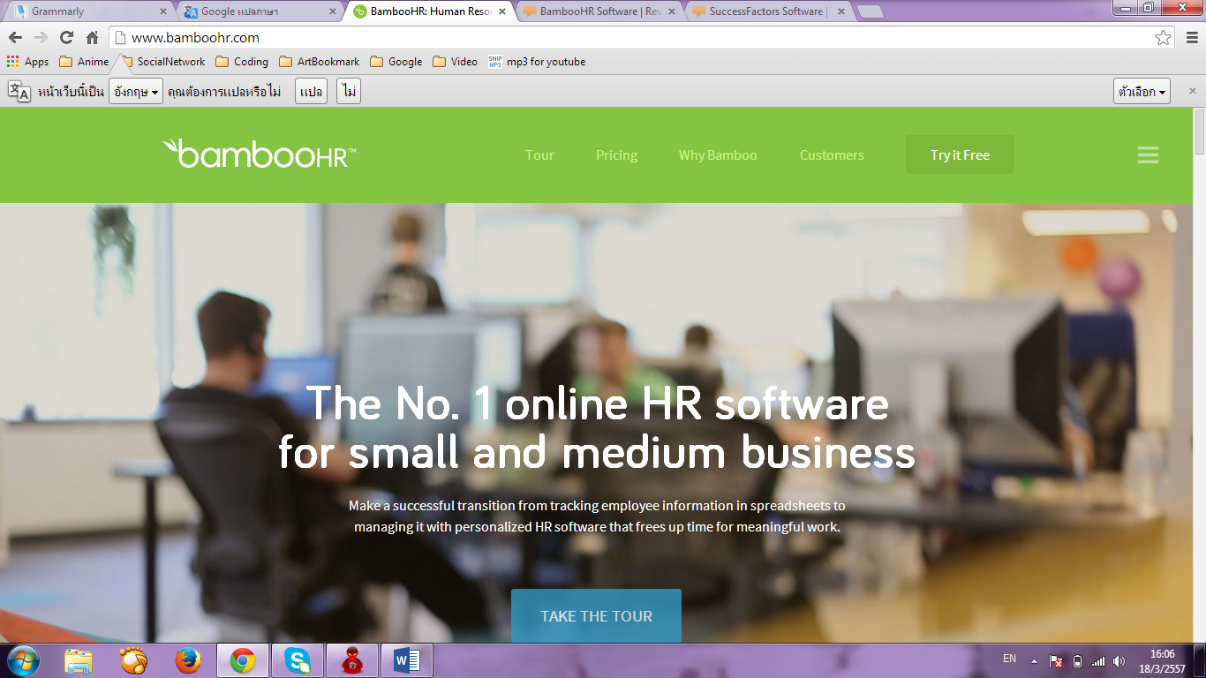**2.2.3 http://www.bamboohr.com/** [?]

**Figure 2.2.3 http://www.bamboohr.com**

BambooHR is an online HR software service for small and medium-sized businesses. As the price/performance leader, BambooHR makes it easy and affordable for small and growing companies to transition from spreadsheets to a Human Resource Information System (HRIS) that adapts to their changing needs. HR professionals can focus their time on meaningful work by using BambooHR’s Applicant Tracking System (ATS) and HRIS to manage all aspects of the employee lifecycle.

**Pros**  
 -BambooHR have compare system between software personnel

-high Human resource system management for support enterprise

**Cons**

-didn’t have function to support freelancer

-low independence define resume for freelancer

**2.3 Technology Review  
  
 2.3.1 HTML5**

**Figure 2.3.1 HTML5 logo**

**Development Tool Description** HTML is a language for describing web pages. HTML5 is the latest standard for HTML. It is a markup language to create a webpage and present contents that can be displayed in a web browser. [1]  
  
 **Alternative tool.**  
 - HTML4. **The selection of this tools.** - To read HTML documents and display them as web pages.

**2.2.3** **Cascading Style Sheets 3 (CSS3)**



**Figure 2.2.3 CSS3 logo**

**Development Tool Description**

CSS3 is stands for Cascading Style Sheets 3. It define how to display HTML elements

**The selection of this tools.** To handle displaying html on web site.

**2.2.4 JavaScript**

**Figure 2.2.4 JS logo**

**Development Tool Description**  JavaScript is a scripting language is a lightweight programming language.

JavaScript is programming code that can be inserted into HTML pages.

JavaScript code can be executed by all modern web browsers.

**Alternative tool.**  
 -JSX

**The selection of this tools.  
 -** Allow many page effects.

**2.4Development Tool Review**

**2.4.1 ASP.Net MVC4**

**Figure 2.4.1 ASP.Net MVC4 logo**

**Development Tool Description**  
 ASP.NET MVC 4 is a framework for building scalable, standards-based web  
 applications using well-established design patterns and the power.  
  **The selection of this tools.  
 -**Building enterprise web applications.  
 -Using the Model View Control (MVC) features.

**2.4.2 C# ( Programing language)**

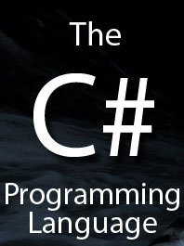

**Figure 2.4.2 C# ( Programing language)**

## **DevelopmentToolDescription** C# is an elegant and type-safe object-oriented language that enables developers to build a variety of secure and robust applications that run on the .NET Framework. You can use C# to create Windows client applications, XML Web services, distributed components, client-server applications, database applications, and much, much more. Visual C# provides an advanced code editor, convenient user interface designers, integrated debugger, and many other tools to make it easier to develop applications based on the C# language and the .NET Framework. **Alternativetool.** -VisualBasic **-**Visual C++

**The selection of this tools.  
 -**Tools for developing software.  
 -Work with asp.net mvc4.

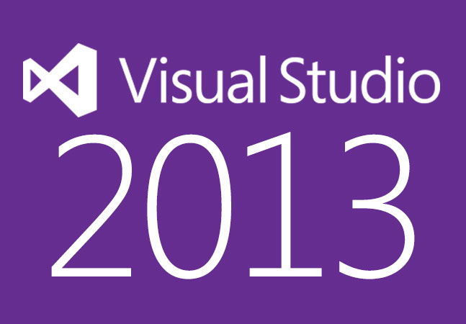**2.4.3 Visual studio 2013**

**Figure 2.4.3 Visual studio 2013 logo**

**Development Tool Description**  
 Visual Studio 2013, a family of products, tools, and technologies that you can use to build powerful, high-performance apps. You can use the resources in this topic to learn how to create Windows Store apps, in addition to desktop, web, phone, and game-console apps, in this release of Visual Studio.

**Alternative tool.**  
 **-**Visual Studio .NET.

**-**Visual Studio2012.

**The selection of this tools.  
 -**Provide c# and asp.net inside.

**-**latest version with enhanced featuresthan Visual Studio2012.

**2.4.5 Google Chrome**



**Figure 2.4.5 Google Chrome logo**

**Development Tool Description**Google Chrome is a free-ware web browser which developed by Google, Inc. Google Chrome combines a minimal design with sophisticated technology to make the web faster, safer, and easier.

**Alternative Tool**

-IE (Internet Explorer)

**The selection of this tool**

-To run application.

-Supported HTML5.

-Supported CSS3.

-Fast to load web pages.

**2.4.6GitHub**

**Figure 2.4.6 Github logo**

**Development Tool Description**  
 GitHub is a [web-based hosting service](http://en.wikipedia.org/wiki/Shared_web_hosting_service) for software development projects that use the [Git](http://en.wikipedia.org/wiki/Git_(software)" \o "Git (software)) [revision control](http://en.wikipedia.org/wiki/Revision_control) system. GitHub offers both paid plans for private repositories, and free accounts for [open source](http://en.wikipedia.org/wiki/Open_source) projects.

**Alternative Tool**

**-** SVN tortoise.

**The selection of this tool**

- Participate with another member.

-be able to identity version control.

-shared file.

# **Chapter Three Quality Standard**

3.1 ISO 29110

In order to establish the most standard software. We establish our software based on ISO29110 .What is ISO29110? Standard ISO / IEC 29110 is international software engineering standards, the International Organization for Standardization. It is a standard that focuses on a small software development. Used to raise the quality of the software products and services are recognized internationally that integrated in the development of continuous improvement.

Currently, ISO / IEC 29110 is a new standard for enterprise and has been widely used internationally. ISO/IEC 29110, under the general title *Software engineering — Lifecycle profiles for Very Small Entities (VSEs).* For the purpose of ISO/IEC 29110, a VSE is an entity (enterprise, organization, department or project) having up to 25 people. VSEs also develop and/or maintain software that is used in larger systems. Therefore, recognition of VSEs as suppliers of high quality software is often required.

3.1.1 Project management process

First, definition of project is temporary in that it has a defined beginning and end in time, and therefore defined scope and resources. The development of software for an improved business process, the construction of a building or bridge, the relief effort after a natural disaster. Therefore Project management is the application of knowledge, skills and techniques to execute projects effectively and efficiently. It’s a strategic competency for organizations, enabling them to tie project results to business goals

The purpose of Project management process for the systematic performance of the analysis, design, construction, integration and test actives for new or modified software products according to the specified requirements.

Selected process

3.1.1.1 Project planning process

3.1.1.2 Project plan execution process

3.1.1.3 Project assessment and control process

3.1.1.4 Project closer process

3.1.2 Software implementation process

 A systematically structured approach to effectively integrate a [software](http://en.wikipedia.org/wiki/Software) based service or component into the workflow of an organizational structure or an individual end-user. The purpose of the software implementation process is the systematic performance of the analysis, design, construction, integration and test actives for new or modified software products according to the specified requirements.

Selected process

3.1.2.1 Software implementation process

3.1.2.2 Software requirement analysis process

3.1.2.3 Software architectural design process

3.1.2.4 Software construction process

3.1.2.5 Software integration process and test process

3.1.2.6 Software delivery process

# 

# **Chapter Four | Project Plan**

## 4.1 Motivation

Nowadays, Job related software side is extremely competitive. Software personnel want to find job that match with own capacity don’t have directly web application for software side. But they have to find on a web based applications to find job. Which might make the job do not match with capacity. This web application will target on finding software job side only for find jobs that match with the software produce process in each side. And help Software personal to find out job that match with their capability or software task process in software project. And promote their own software specialist skills. In addition this software enterprisers will be find out software specialist that match with their software project task process or software job.

## 4.2 Aims and Objectives

**4.2.1 Aims**

This project aims to developed software job or software task process web application. For software personnel to be find out software project task or software job that match or related with their capability. And help them to promote their specialist skill by comment form Completion software work. Or vote form software entrepreneur.In addition aim to develop in term of software entrepreneur for find out software personnel to match with project.

**4.2.2 Objective**

## 4.3 System Architecture

## C:\Users\SAMSUNG\Desktop\Untitled Diagram.png

Figure 4.3.1: Overall Web-application

Figure 4.3.1 shows the overall of TEAM DUTY system. The system consist of Client use internet to connect with the Browser to request to asp.net MVC service and send to the Database(SQL Server) via the webserver (IIS7)

*Client is all of three type should use same architecture*

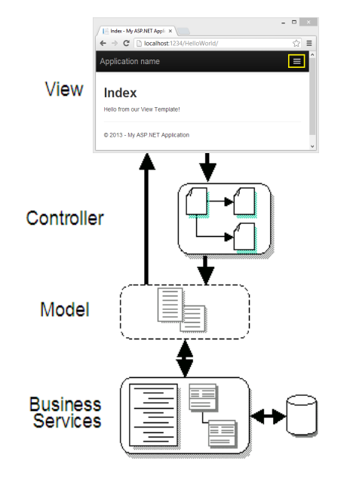

Figure 4.3.2: MVC Web-application Architecture

The Model-View-Controller (MVC) architectural pattern separates an application into three main components: the model, the view, and the controller The ASP.NET MVC framework provides an alternative to the ASP.NET Web Forms pattern for creating MVC-based Web applications. MVC is a standard design pattern that many developers are familiar with. Some types of Web applications will benefit from the MVC framework. Others will continue to use the traditional ASP.NET application pattern that is based on Web Forms and post backs. Other types of Web applications will combine the two approaches; neither approach excludes the other.

MVC framework includes the following components:

**Models**. Model objects are the parts of the application that implement the logic for the application s data domain. Often, model objects retrieve and store model state in a database. For example, a Product object might retrieve information from a database, operate on it, and then write updated information back to a Products table in SQL Server.

**Views**. Views are the components that display the application s user interface (UI). Typically, this UI is created from the model data. An example would be an edit view of a Products table that displays text boxes, drop-down lists, and check boxes based on the current state of a Products object.

**Controllers**. Controllers are the components that handle user interaction, work with the model, and ultimately select a view to render that displays UI. In an MVC application, the view only displays information; the controller handles and responds to user input and interaction. For example, the controller handles query-string values, and passes these values to the model, which in turn queries the database by using the values.

## 4.4 Deliverables and Limits

**4.4.1 Deliverables**

**4.4.1.1 System Overview**

**Account management system:**

TEAMDUTY allows users involve Software-entrepreneur and Software-personnel to manage the information. The both information of them will consist of member id, type, and their profile (include other title that will be relate with user ex. software specialist). This part will include function that both of Software-entrepreneur and Software-personnel can do within it like comment or vote. Within account system we will provide system to validate account

**Software-service request customer management system:**

Part of Software-entrepreneur to manage everything about their project and profile. Ex project title type of project or software-personnel that interested in project within system. This part will be have function that only Software-entrepreneur can do within it.

**Software- freelance supply team management system:**

Part of Software-personnel to manage about their own history, Employment and resume Ex task status, profile manage. This part will be have function that Software-personnel can do within it.

**Software – Account management system:**

Part of Administrator to validate account of freelancer.

**4.4.1.2 Software Document**

* Project Proposal
* Project Plan
* Software Requirement Specification
* Software Design Document
* Testing Document
* Test Plan  
  - Unit Test Document  
  - System Test Document
* Test Report  
  - Unit Test Document  
  - System Test Document
* Traceability Record
* Progress Status Report
* Self-Assessment Report

## **4.4.2 Limits**

* Internet connection is required for using TEAM DUTY web application.
* Web browser is required for using TEAM DUTY web application.
* User must to be member before using TEAM DUTY web application.
* User will be using username in form email address web application.
* Web application support only Thai language

## 4.5 Schedule & Milestones

The schedule and milestones of the learning through activities system**.** During period of time, there are work terminologies. And the description is shown below that:

**Have three type of User**  
 -First is **service request customer**

-Second is  **freelance supply team**

-Third is  **administrator**

**Feature that both of user can do:**

Feature01: -Registration system

Feature02: -Login system (can be via Facebook account)

Feature03: -Online Status system

Feature04: -Account Validate system

Feature05: -Completed tasks system (can be see Work Experience of Software-personal)

Feature06: -Profile system (Show profile)

**Feature for service request customer:**   
 Feature07: -Project detail system (provide detail of software project)

Feature08: -search system (can search by categories or some keyword ex MySQL)

Feature09: -Project interested system (view name list software personal that interested in project)

Feature10: -vote system (vote software-personal)

Feature11: -older form system (Use the form existing to be created new project)

Feature12: -request Software-personal system (request software-personal to be join project)

**Feature for freelance supply team**:

Feature13: -Project search system (search project by keyword or categories)

Feature14: -Request task system (request to entrepreneur that interest in project)

Feature15: -see project detail system

Feature16: -teammate project system (to see other person that join to do project)

Feature17: -task status system (title status to receive work or not)

**Feature for Administrator**

Feature18: -verify freelancer system (verify in each system)

**Feature Table**

|  |  |  |  |  |  |
| --- | --- | --- | --- | --- | --- |
| No | Name | Description | User(s) supported | | |
| **service request customer** | **freelance supply team** | **Administrator** |
| 11 | older form system | Explain what it is for… | V |  |  |
|  |  |  |  |  |  |

|  |  |  |  |
| --- | --- | --- | --- |
|  |  |  |  |
|  |  |  |  |
|  |  |  |  |
|  |  |  |  |
|  |  |  |  |
|  |  |  |  |
|  |  |  |  |

|  |  |  |  |
| --- | --- | --- | --- |
|  |  |  |  |
|  |  |  |  |
|  |  |  |  |
|  |  |  |  |
|  |  |  |  |
|  |  |  |  |
|  |  |  |  |

**4.5.2 Milestones**

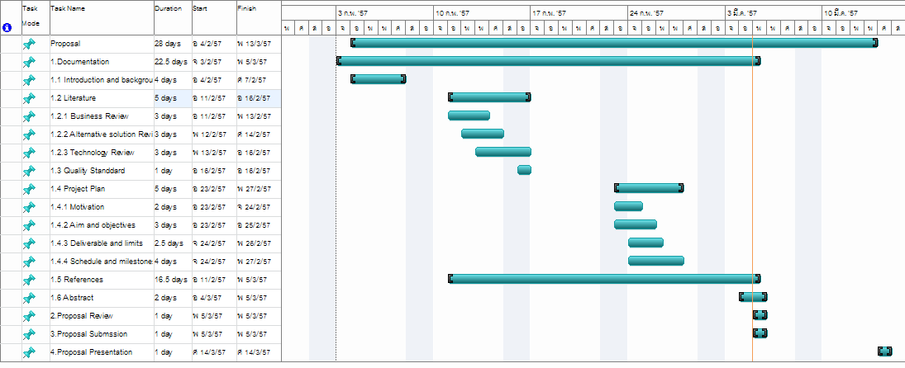

## 

## 

## 

# Chapter Five | References

[1] <https://www.freelancer.com/>

[2] http://www.freelance-hub.com/

## [3] http://www.w3schools.com/html/html_intro.asp

## [4] http://evincetech.wordpress.com/2013/02/02/pros-cons-of-html5/

## [5] http://en.wikipedia.org/wiki/HTML5#cite_note-HTML5-20110405-2

## [6] http://www.w3schools.com/css/css_intro.asp

## [7] http://www.asp.net/mvc/mvc4

## [8] http://msdn.microsoft.com/en-us/library/aa983532(v=vs.71).aspx

## c#

## [9] http://msdn.microsoft.com/en-us/library/kx37x362.aspx

## [10] http://www.visualstudio.com/

## [11] https://www.google.com/intl/en/chrome/browser/

## [12] http://www.asp.net/mvc/tutorials/security/using-oauth-providers-with-mvc

## [13] http://www.nuget.org/packages/XSockets.Sample.WebRTC/0.7.9